Keash/Culfadda Newsletter May 14th 2023
Sixth Sunday of Easter
Year A
Phone: Fr. Gabriel Murphy (086)3429686
Notices for Newsletter email: gmurphy@achonrydiocese.org
For more information visit our Website: www.keashparish.ie –
Masses from Culfadda Church are Live streamed, please visit www.keashparish.ie

St Kevin’s Church Keash.
Saturday 13th 8.00pm Dominick & Margaret Lavin, Broher.
Wednesday 17th 10.00am People of the parish.
Friday 19th 10.00am.
Saturday 20th 8.00pm People of the parish.

Our Lady of the Rosary Church Culfadda.
Sunday 14th 10.00am Michael Higgins, Townaghline (25th Anniversary).
Monday 15th 10.00am.
Tuesday 16th 10.00am.
Saturday 20th 11.30am First Holy Communion for Culfadda N.S. Children.
Sunday 21st 10.00am Vincent & Monica O’ Shea, Dublin and Cloontycairn, also
Frank Higgins, Rathmullen (10th Anniversary), also
Margaret & Jack Higgins, Townaghmore.
Readers.
Saturday 13th Breda Forkin. Sunday 14th Sharon Hunt.
Saturday 20th Martin Tansey. Sunday 21st Ann Brehony.

Recent Deaths.
Your prayers are requested for Franz Hufsky who died in Germany (father-in-law of Sandra Gormley, Rathmullen), also, Paddy Redican Sydney, Australia (brother-in-law of Nancy Redican, Townaghmore). May their souls rest in peace. Amen.
Parish Pastoral Council.
The members of the Parish Pastoral Council are; Joseph Hannon (Chairperson), Margaret Cryan Jnr (Secretary), William Henry (Communications Officer), Bernadette Brehony, Marian Kielty, Damien Carty, Eileen Gormley, Mary Dwyer, Margaret Cryan Snr & Fr Gabriel Murphy.
The Pastoral Council met on Wednesday 3rd May for the first time since attending recent training on the function of a Pastoral Council and the role of its members. A very positive meeting was had. A lack of a social focal point and opportunity for people in the parish to meet up was discussed. Over the coming months the Pastoral Council will be organising some social meet up events aimed at people of all ages across the parish. If you have any ideas, or is there is a particular event you would like to see organised or revived in the parish, please do let us know. Also, we would like to see new Ministers of the Eucharist, Counters and Cleaners for both Churches, if you are willing to help out it would be very much appreciated. Training will be provided for Ministers of the Eucharist, our aim is to have twelve, so that it will not be a burden on anyone. Please let Fr Gabriel know or any member of the Pastoral Council. Your input would be very welcome.
Keash/Culfadda Community Games – Revised Date.
Keash/Culfadda Community Games will take place at the revised date of Bank Holiday Monday 5th June at 1pm at the Fr Kevin Brehony Memorial Park in Keash. For further details contact Helen Clarke 089 4494305.
Also, the committee would like to thank the parishioners for their generosity and support of the recent church gate collection. A total of €400 was raised.

Culfadda Community Centre.
Work is progressing very well on the new extension and we are pushing to renovate the existing hall to a high standard to include new floor, new electrical fitout, underfloor heating, audio system and external insulation. This will be a huge addition to our community and for all the people to enjoy when it is finished.
The committee are pleased to announce our new fundraising campaign, a social night in the Dapper Duck, Gurteen, with live music, on Saturday night 8th of July, more news on this to follow in the coming weeks. On that night we will be holding a raffle with 1st prize €500 and other great cash prizes + more prizes on the night. Tickets will be on sale from this weekend and could make great gift ideas for birthday/thank you cards etc.
Please support our raffle which is in aid of the new community centre and you could be in with a chance of winning our cash prizes on the night. Tickets - €10 each or 3 for €20 and are available from all committee members.
Text, call or WhatsApp 087 9223924 for more details on where/who to purchase tickets from. Thank you for your support for the first major community development in the village for some time. Tickets for our Fundraising raffle on the 8th of July will be available after masses in the parish at the weekends. Please support this great development in our community and be in with a chance of winning our €500 top prize + other cash prizes on the night. Your support is appreciated as we push to raise funds to complete all works. Tickets will be available from Committee members. 087 9223924 for any more details, text your name if you wish to be added to the Community Centre WhatsApp group. Thank you. 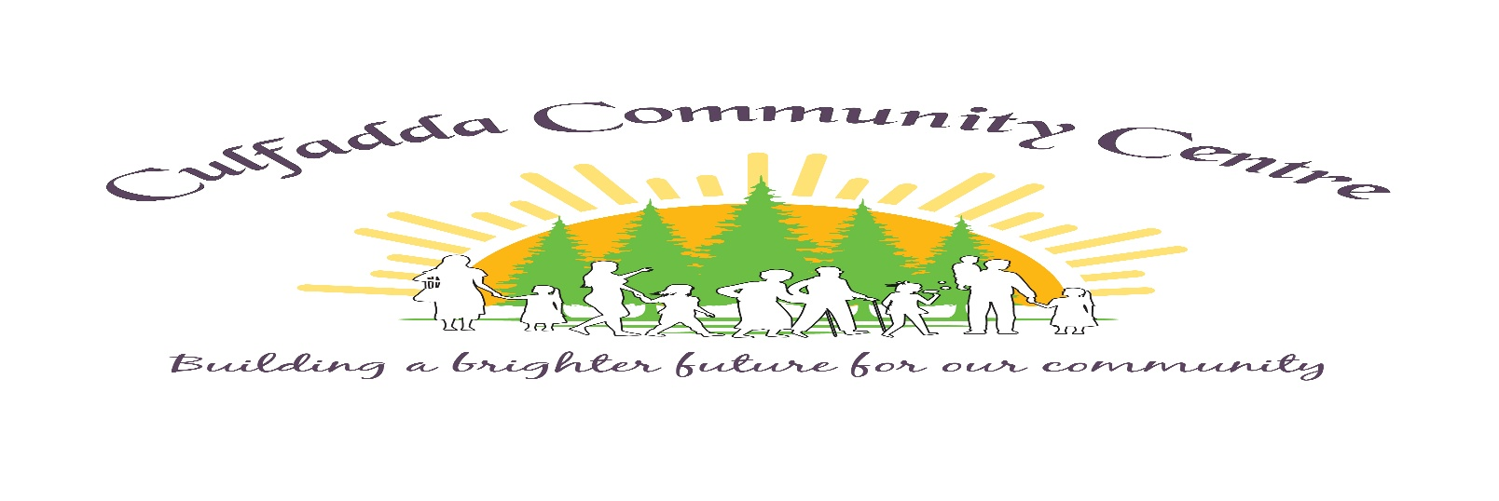
Achonry Diocesan Pilgrimage to Knock.
The Pilgrimage takes place on Sunday 21st May. All parishioners are invited to come to Knock for this day of prayer and reflection. The official Programme is as follows - 2pm Rosary, 2:30pm Anointing of the Sick in the Basilica, 3pm Concelebrated Mass in the Basilica, Followed by Benediction and Rosary. Our Lady Of Knock, Pray for us.
Keash Church Renovation Fund.
Total received to date €19,124
We wish to acknowledge having received a donation of €100 towards Keash Church Renovation Fund. We have to raise approximately €65,000 to pay for the cosmetic works. Thank you to everyone for their ongoing generosity and support. ‘For all things come from you, and of your own have we given you’ 1 Chronicles 29:14b.

Keash Parish Online Donations
www.keashparish.ie

Please Donate Online,

Thank you for your support.

