Keash/Culfadda Newsletter May 7th 2023

Fifth Sunday of Easter
Year A

Phone: Fr. Gabriel Murphy (086)3429686
Notices for Newsletter email: gmurphy@achonrydiocese.org
For more information visit our Website: www.keashparish.ie –
Masses from Culfadda Church are Live streamed, please visit www.keashparish.ie

St Kevin’s Church Keash.
Saturday 6th 8.00pm People of the parish.
Wednesday 10th 10.00am James & Margaret Cryan Toomour, their daughter Mary, also Annie
May Cryan and her daughter Catherine, Ballinafad.
Friday 12th 10.00am.
Saturday 13th 8.00pm Dominick & Margaret Lavin, Broher.

Our Lady of the Rosary Church Culfadda.
Sunday 7th 10.00am Special intention.
Tuesday 9th 10.00am.
Sunday 14th 10.00am Michael Higgins, Townaghline (25th Anniversary).

Saturday 6th James Duffy. Sunday 7th Kieran Kielty.
Saturday 13th Breda Forkin. Sunday 14th Sharon Hunt.
Keash/Culfadda Community Games – Thankyou
Keash/Culfadda Community Games would like to thank the parishioners for their generosity and support of the recent church gate collection. A total of €400 was raised.
Note the games will take place on Sat 13th May at 2pm at the revised venue of Ballinafad.
For further details contact Helen Clarke 089 4494305.
Achonry Diocesan Pilgrimage to Knock.
The Pilgrimage takes place on Sunday 21st May. All parishioners are invited to come to Knock for this day of prayer and reflection. The official Programme is as follows - 2pm Rosary, 2:30pm Anointing of the Sick in the Basilica, 3pm Concelebrated Mass in the Basilica, Followed by Benediction and Rosary. Our Lady Of Knock, Pray for us.
Accord – Join our Marriage Preparation Team.
Accord is currently recruiting volunteers to train as marriage preparation facilitators. Marriage facilitators are part of a team that prepare couples for the Sacrament of Marriage. Couples find our courses fun, engaging and very relevant, while facilitators gain valuable life skills. If you are interested, we would be delighted to hear from you. please contact marriagepreparation@accord.ie or call on 01-5053112 for more information.
Coleman Music Centre.
Shaskeen will perform a live concert in the Coleman Music Centre on Sat May 20th at 8pm. Tickets are now on sale 071 9182599 or visit our website www.colemanirishmusic.com. Traditional Irish Music and Song has been at the forefront with Shaskeen for the last fifty three years, Shaskeen is now a recognised cornerstone in the Irish Traditional and Folk scene. Susan McCann, Ireland’s First Lady of Country music – Live concert in the Coleman Music Centre in Gurteen Co. Sligo on Sat May 13th at 8pm. Fantastic night of music & song guaranteed. Show starts at 8pm. €25 Tickets available online www.colemanirishmusic.com or call 071 9182599.

Culfadda Community Centre.
Work is progressing very well on the new extension and we are pushing to renovate the existing hall to a high standard to include new floor, new electrical fitout, underfloor heating, audio system and external insulation. This will be a huge addition to our community and for all the people to enjoy when it is finished.
The committee are pleased to announce our new fundraising campaign, a social night in the Dapper Duck, Gurteen, with live music, on Saturday night 8th of July, more news on this to follow in the coming weeks. On that night we will be holding a raffle with 1st prize €500 and other great cash prizes + more prizes on the night. Tickets will be on sale from this weekend and could make great gift ideas for birthday/thank you cards etc.
Please support our raffle which is in aid of the new community centre and you could be in with a chance of winning our cash prizes on the night. Tickets - €10 each or 3 for €20 and are available from all committee members.
Text, call or WhatsApp 087 9223924 for more details on where/who to purchase tickets from. Thank you for your support for the first major community development in the village for some time. 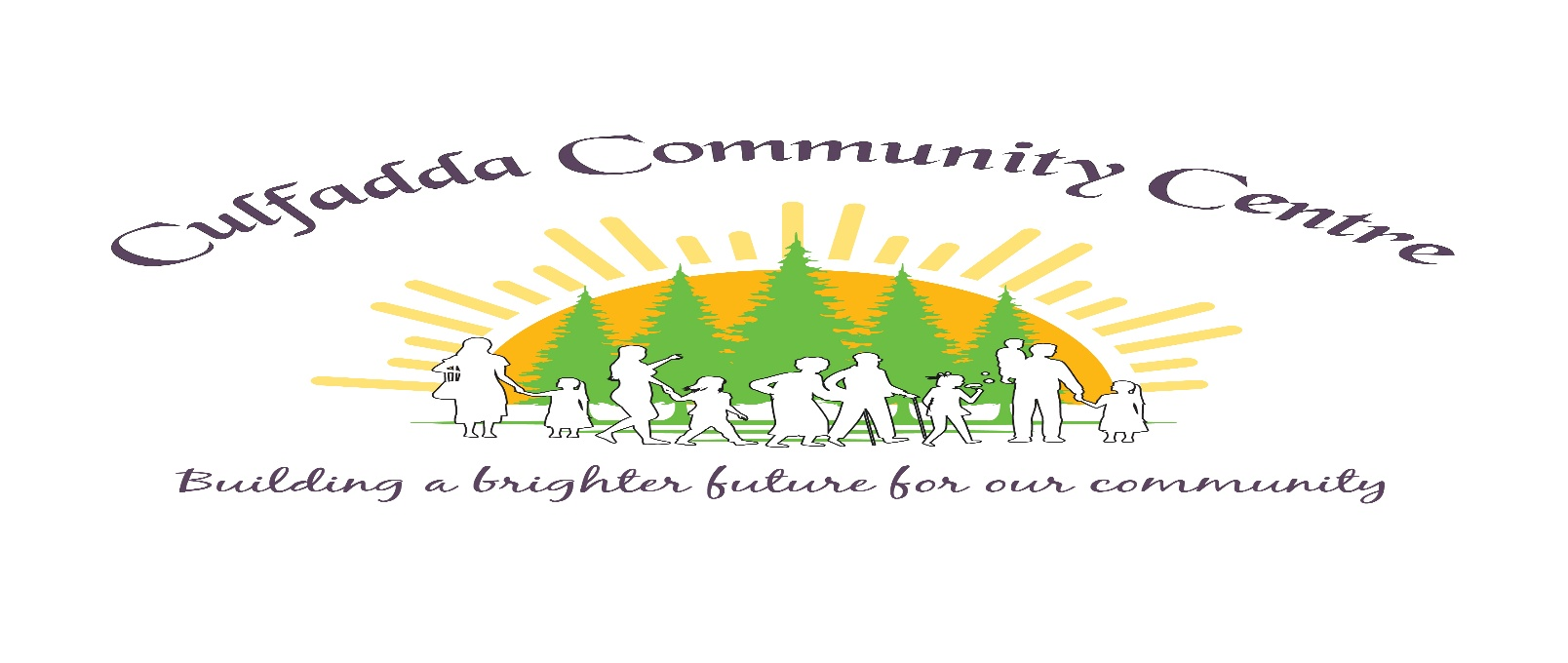

Keash Church Renovation Fund.
Total received to date €19,024
We wish to acknowledge having received donations of €200 & €150 towards Keash Church Renovation Fund. We have to raise approximately €65,000 to pay for the cosmetic works. Thank you to everyone for their ongoing generosity and support. ‘For all things come from you, and of your own have we given you’ 1 Chronicles 29:14b.

Keash Parish Online Donations

www.keashparish.ie

Please Donate Online,

Thank you for your support.

